**ABOUT US**

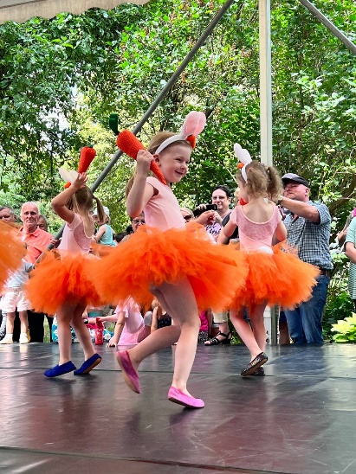

**Our Mission:**  
Our efforts are aimed at making dance an accessible and enjoyable activity for children everywhere. We strive to create an environment where every child can unlock their potential, find joy in movement, and express themselves through dance without having to leave their hometown or village.

**Where?**

We started our work in 2022, and to this day, we operate in three locations:

**\* Störnstein**

**\* Windischeschenbach**

**\* Erbendorf**

We have over **100 children** dancing with us already.

We are ready for expansion. If you'd like our studio to start operating near you, just get in touch with us.

We will do everything possible to ensure that your child or you yourself can dance as close to home as possible.

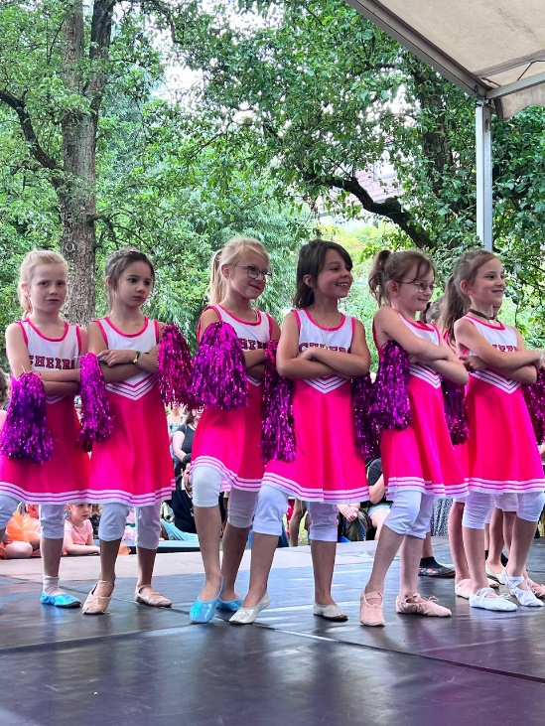

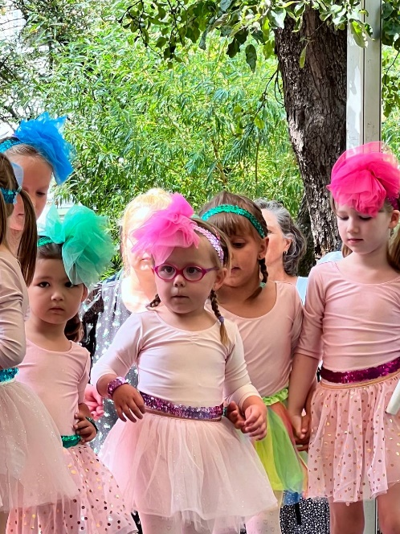

**For Whom?**

We work with children of all ages, starting from three years old.

We operate in three main age groups:

* preschool (age 4-6),

* elementary school (age 6-9),

* teenagers (age 10-16).

Additionally, we have a course for adults.

We welcome anyone who wants to dance with us.

**Our main Courses:**

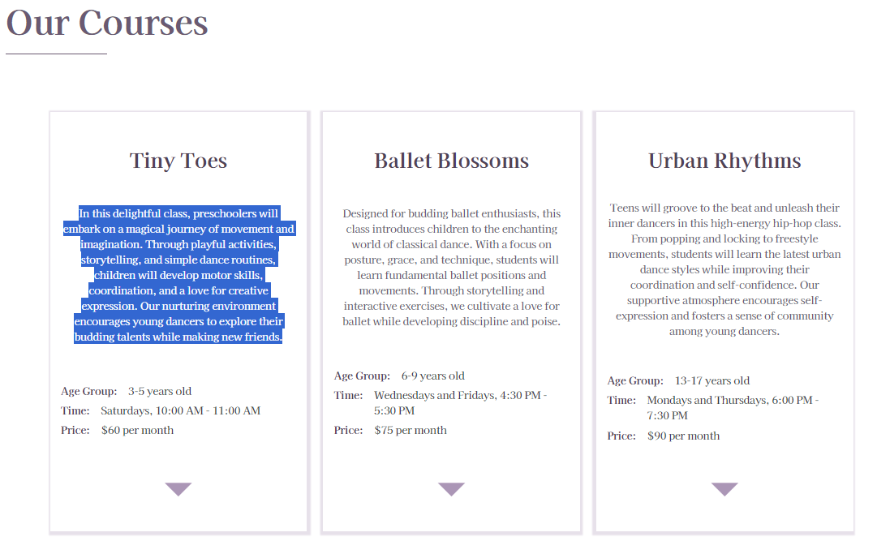

**Timetabel**

**Mittwoch**

|  |  |  |
| --- | --- | --- |
| 14:00 – 14:45 | Minies (ab 4 Jahren) | Erbendorf |
| 15:00 – 16:00 | Kids (ab 6 Jahren) | Erbendorf |
| 17:00 – 18:00 | Teens (ab 9 Jahren) | Windischeschenbach |
| 18:00 – 19:00 | High Heels (Erwachsene) | Windischeschenbach |

**Donnerstag**

|  |  |  |
| --- | --- | --- |
| 14:00 – 14:45 | Minies (ab 4 Jahren) | Windischeschenbach |
| 15:00 – 16:00 | Kids (ab 6 Jahren) | Windischeschenbach |

**Freitag**

|  |  |  |
| --- | --- | --- |
| 13:30 – 14:15 | Minies (ab 3 Jahren) | Störnstein |
| 14:15 – 15:00 | Minies (ab 4 Jahren) | Störnstein |
| 15:00 – 16:00 | Kids (ab 7 Jahren) | Störnstein |
| 16:00 – 17:00 | Kids (ab 6 Jahren) | Störnstein |
| 17:00 – 18:00 | Teens (ab 10 Jahren) | Störnstein |